Marquis Sills

4/12/2023

**Module-4 Report**

The top five performing schools are as followed Cabrera High School, Thomas High School, Griffin High School, Wilson High School, and Pena High School. All of the top five schools are charter schools. These top performing schools have an overall pass-rate at over 90%. The lowest performing schools are as followed Rodriguez High School, Figueroa High School, Huang High School, Hernandez High School, and Johnson High School. The lowest performing schools are all districts with an overall pass-rate of around 53%. What is important is to figure out why such a disparity.

In the dataset, we compared academic performance to the schools funding per student.

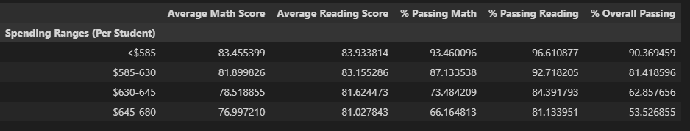

The dataset shows that there is a negative correlation between spending per student and the academics performance. This appears paradoxical, so further investigation must be made.

An output based on academic performance and the number of students per school is shown.

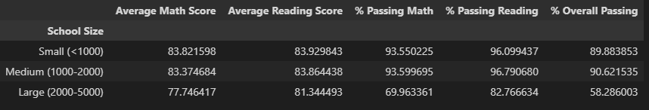

This output shows that there is a negative correlation between the number of students and the overall pass rate; the bigger the school the worse the students perform.

The last output shows that the best performing schools are the charter schools.

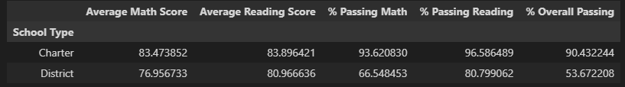

The top five schools and the bottom five schools have an approximately equivalent funding per student. However, the number of students per school is not the same. The bottom five performing schools have significantly more students than top performing schools. This does explain why those bottom five schools have a larger school budget than the top five schools. Perhaps there is a correlation between funding and the number of students, but a weak correlation between academic performance and funding.

We cannot discount that the top five schools are charter schools and bottom performing are districts. The school structure or teaching method for charter schools appears performs better than district schools. However, we deduce that size is the deciding factor because the average number of students for districts is greater than the number of students in charter schools as shown below.

